**Guide to Using AJPAM's Online Journal System (OJS)**

**Platform URL:** <https://ajpam.aapam.org/index.php/ajpam>

**1. User Registration**

**For Editors & Submitters:**

1. Go to the homepage: <https://ajpam.aapam.org/index.php/ajpam>
2. Click **"Register"** at the top right corner.
3. Fill in your details:
   * Username, Password, Email
   * Affiliation and Country
   * Select roles: *Author*, *Reviewer* or *Editor* (as appropriate)
4. Agree to the privacy statement.
5. Click **"Register"** to complete.

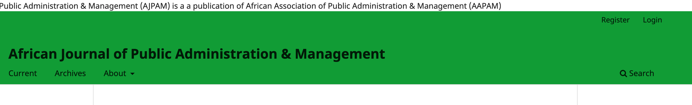

**2. Article Submission (Author)**

1. Log in and go to the **Dashboard**: <https://ajpam.aapam.org/index.php/ajpam/submissions>
2. Click **"New Submission"**.
3. Follow the 5-step process:
   * **Start**: Select section (e.g., Articles), agree to submission requirements.
   * **Upload Submission**: Upload manuscript and supplementary files.
   * **Enter Metadata**: Provide title, abstract, keywords, and author info.
   * **Confirmation**: Confirm submission.
   * **Next Steps**: See submission listed under "My Queue."

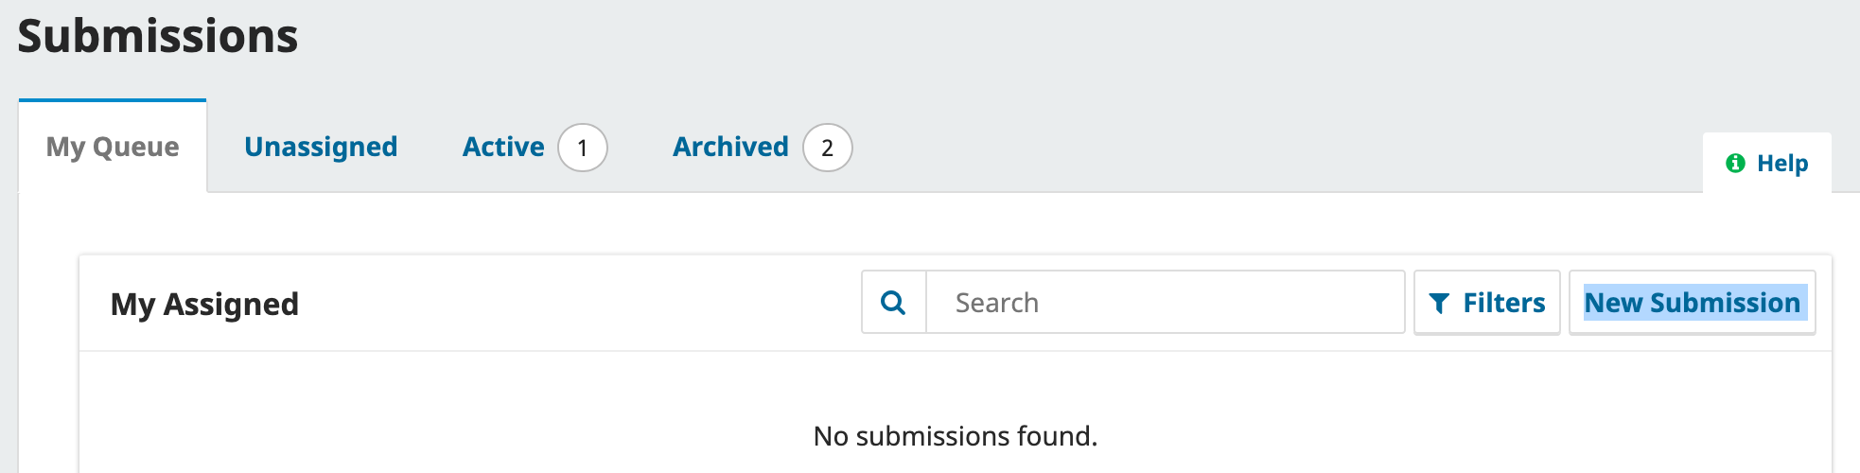

**3. Editorial Workflow (Editor)**

1. Go to **Submissions** in the Dashboard.
2. Click on an article to view details.
3. Use the left-hand panel to move through stages:
   * **Submission**: Assign Section Editor.
   * **Review**: Assign reviewers, monitor progress.
   * **Copyediting**: Add copyeditors and communicate with authors.
   * **Production**: Upload final galley files.
4. Use **Discussion** tools to communicate with authors and reviewers.

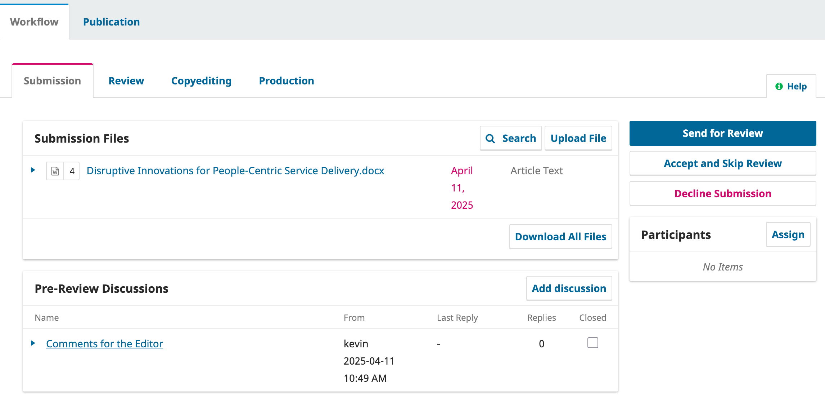

**4. Reviewing (Reviewer)**

1. Log in and go to the **Reviewer Dashboard**.
2. Click a submission under **"Assigned"**.
3. Review submission file and instructions.
4. Enter decision: *Accept*, *Revisions Required*, or *Decline*.
5. Upload reviewer comments (if any).
6. Submit review.

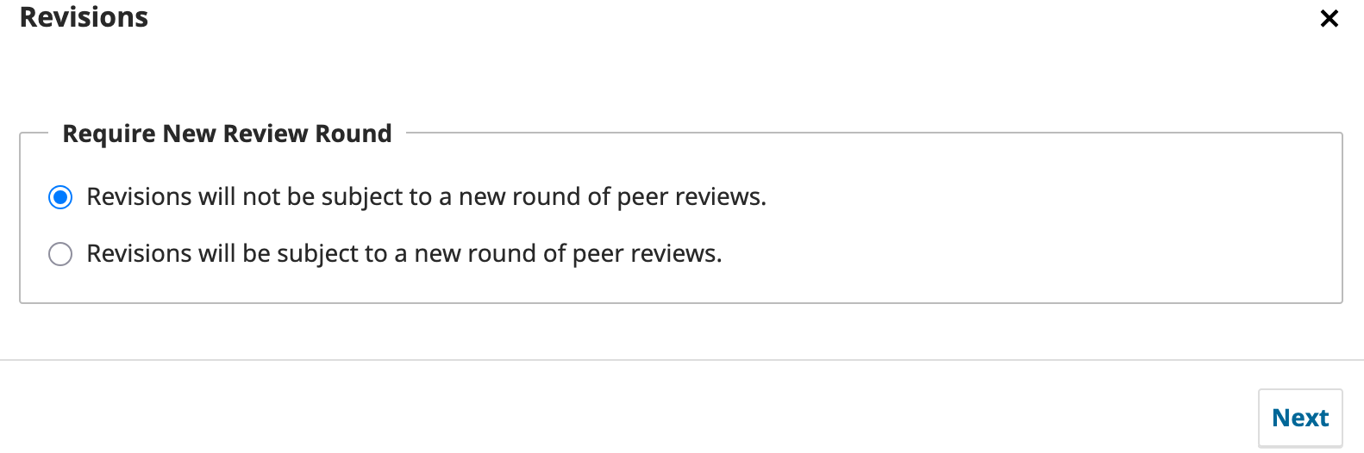

**5. Final Decision and Publication (Editor)**

1. Make editorial decision after peer review.
2. Notify author via the **Editorial Decision** tab.
3. Move submission to **Production**.
4. Upload formatted galley files (PDF, HTML, etc.).
5. Schedule for publication in an issue.
6. Publish the issue.

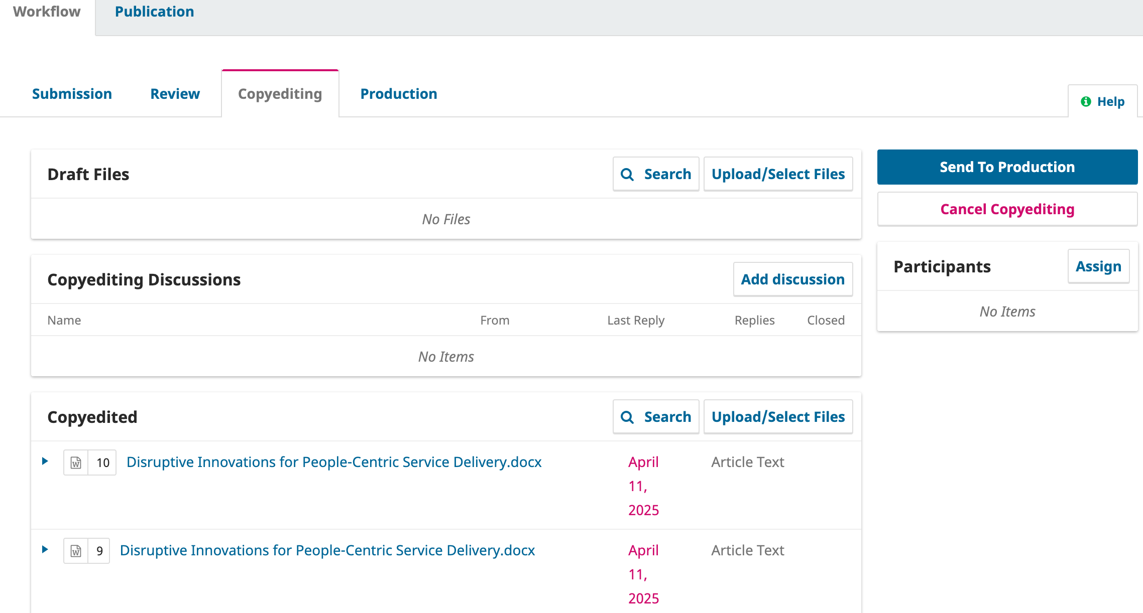

**Need Help?**

* Visit the Help link on the site: <https://ajpam.aapam.org/index.php/ajpam/help>
* Email: [kevin@aapam.org](mailto:kevin@aapam.org), [support@aapam.org](mailto:support@aapam.org)

Let’s make knowledge sharing seamless!